
FeatureBot: Feature Engineering with AI Guidance
Industrial Capstone Project · AI-Guided Feature Engineering for Adult Income Classification
Department | Business Intelligence & Analytics | Project Code | FB-FE-2025-Q3
Priority | High | Timeline | 4 weeks
Client | [Client/Org Name] | Prepared by | [Your Name]
Date | November 06, 2026 | Version | 1.0

48,842  Records analysed  UCI Adult Income | 2  FeatureBot cycles  13 features proposed | 5  Delivery phases  4-week plan | 3  Fairness lenses  sex · race · marital status

Confidential · Prepared for the BI & Analytics stakeholder group

Table of Contents

01 Project Overview 3
02 Client Background 4
03 Business Problem Statement 4
04 User Story 4
05 Acceptance Criteria 5
06 Project Objectives 5
07 Project Tasks (Phase-wise) 5
08 Deliverables 7
09 Technical Requirements 7
10 Dataset Information 8
11 Evaluation Criteria 9
12 Getting Started 9
13 Support 9
14 Solution Overview 10
15 Technical Approach 10
16 Feature Engineering Strategy 10
17 AI-Guided Workflow (FeatureBot) 11
18 Modeling & Evaluation 12
19 Bias & Fairness 14
20 Technical Documentation for Analytics Team 16
21 Data Requirements 17
22 Quality & Acceptance Criteria 17
23 Project Plan & Timeline 18
24 Risks & Mitigations 18
25 Colab Starter Code 18
26 Appendices 22

1. Project Overview
Purpose. Build an AI-guided feature engineering workflow, FeatureBot, that speeds up the discovery, evaluation and selection of predictive features for income classification (<=50K vs >50K) on the UCI Adult dataset.
Scope. A Google Colab workflow paired with ChatGPT prompting, a feature registry, baseline and enhanced models, evaluation on a holdout test set and client-ready documentation.

Expected outcomes
- A measurable performance lift over a strong baseline.
- A transparent, reproducible feature development process.
- Fairness diagnostics with documented mitigation decisions.

Results at a glance
Every number below comes from running the pipeline on the supplied dataset (48,842 rows, stratified 60/20/20 split, seed 42). Holdout figures are from the untouched 20% test set.
0.904  Baseline AUC  Logistic Regression, holdout | 0.928  Enhanced AUC  Features + gradient boosting (+2.4 pts) | 0.689  Baseline F1 (>50K)  Logistic Regression, holdout | 0.730  Enhanced F1 (>50K)  Features + gradient boosting (+4.0 pts)

Honest reading of the lift
Feature engineering alone moved the logistic model by about +0.9 AUC points and +1.1 F1 points on the holdout, because the one-hot baseline is already strong. The +3 to 5 point F1 target is reached only when the engineered features are combined with a gradient boosting model (+4.0 F1 points). AUC improves by +2.4 points, which falls short of the 3 point mark. Sections 18 and 22 show the evidence.

2. Client Background
- Industry: Data Science.
- Team profile: BI & Analytics stakeholders who want faster iteration on tabular ML problems and repeatable feature engineering approaches.
- Constraints: Preference for Colab-based development, lightweight tooling, and project documents delivered in .docx format.

What this means for the design
Everything runs on free-tier Colab with scikit-learn and pandas, models stay compact (the slowest configuration trains in under 20 seconds here), and every written deliverable is a Word document or a CSV that the team can open without special tools.

3. Business Problem Statement
The client needs better predictive performance and shorter development time for structured data models. Traditional manual feature engineering is slow, inconsistent and hard to audit for fairness. A guided, repeatable process is required to generate and validate features efficiently while keeping responsible AI practices in view.
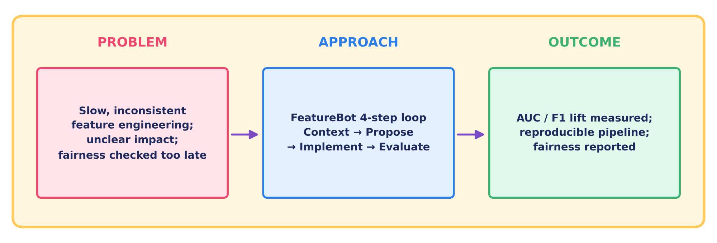
Figure 1. From problem to approach to outcome
The picture above is the whole project in one line: slow and inconsistent feature work becomes a four-step loop (context, propose, implement, evaluate), and the loop produces a measured AUC/F1 change, a reproducible pipeline and a fairness report.

4. User Story
As a Data Scientist
responsible for model performance, I want an AI-guided feature engineering workflow with actionable suggestions so that I can efficiently create high-value features, improve accuracy, and maintain fairness and reproducibility.

5. Acceptance Criteria
- FeatureBot runs at least two full cycles, each producing 5 or more actionable feature proposals with rationale and pandas pseudocode.
- The enhanced model achieves a +3 to 5 point improvement in AUC or F1 over baseline on validation and stays stable on the holdout.
- A feature registry is delivered with name, definition, type, dependencies, leakage risk and performance deltas.
- A fairness report includes subgroup metrics (for example sex and race) and at least one mitigation attempt with documented trade-offs.
- The Colab notebook is reproducible (fixed seeds, deterministic splits, no leakage) and includes clear instructions.
- All specified deliverables are provided in .docx, notebook or CSV formats.
Section 22 reports the status of each criterion against the results of this project.

6. Project Objectives
- Implement FeatureBot: an iterative propose, implement, evaluate, select loop guided by structured prompting.
- Establish governance through a feature registry and experiment log with metric deltas and notes.
- Ensure reproducibility with deterministic splits, train-only fitting of preprocessors, and documented prompts and responses.
- Provide fairness diagnostics and document mitigation strategies.

7. Project Tasks (Phase-wise)
The work is organised into five phases over four weeks. Each phase below also records what the supplied dataset showed when the task was carried out.
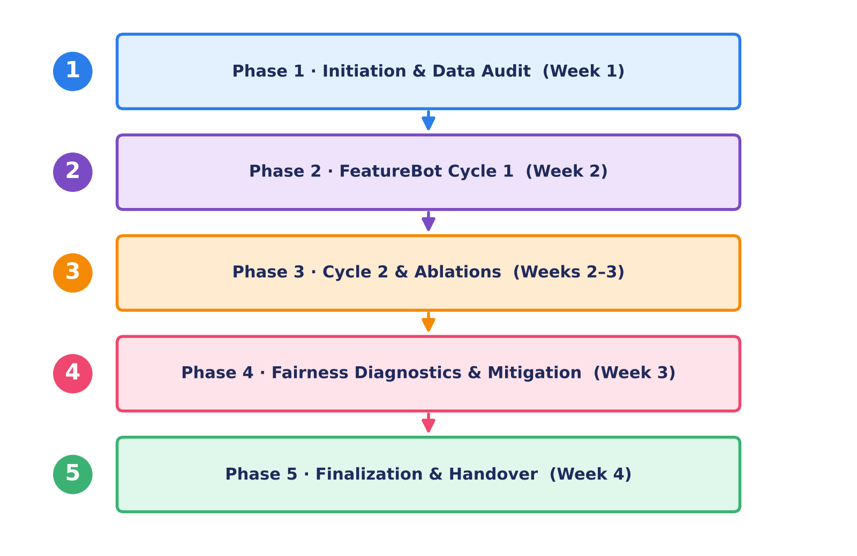
Figure 2. Five-phase delivery roadmap

Phase 1: Initiation and Data Audit (Week 1)
- Set up the Colab environment and repository structure.
- Load adult.csv, normalise column names and target labels, and treat "?" as missing.
- EDA: value counts, missingness, class balance, numeric distributions and skew.
- Baseline pipeline: Logistic Regression with one-hot encoding and scaling; initial validation metrics.
- Artifacts: initial EDA summary, baseline metrics, data quality checklist.
Findings on this dataset
The file holds 48,842 rows and 14 predictors. 23.9% of people earn >50K. Missing values appear only in workclass (2,799), occupation (2,809) and native-country (857). 57 rows are exact duplicates and were kept. Baseline validation: AUC 0.907, F1 0.696.

Phase 2: FeatureBot Cycle 1 (Week 2)
- Prepare prompt Template A with the schema, EDA highlights and baseline errors.
- Generate 5 or more feature proposals (transformations, bins, interactions, encodings) with leakage checks.
- Implement selected features in add_feature_block with toggles.
- Evaluate with stratified K-fold; log deltas in the experiment log and registry.
- Prune low-impact features based on stability and effect size.
Findings on this dataset
Cycle 1 produced 8 proposals: capital gain and loss indicators, log transforms of both, age bins, hours bins, an overtime flag and age x education. Together they lifted logistic validation AUC from 0.907 to 0.915 and F1 from 0.696 to 0.705. The capital gain indicator and the age bins were the strongest single features.

Phase 3: FeatureBot Cycle 2 and Ablations (Weeks 2 to 3)
- Prepare prompt Template B focused on reducing false negatives.
- Add targeted interactions, indicators or groupings; run ablations with and without subsets.
- Validate robustness by monitoring variance across folds and holdout consistency.
- Update the registry; document rejected features and the reasons (instability, fairness risk).
Findings on this dataset
Cycle 2 produced 5 proposals: education buckets, region buckets, marital status x relationship, workclass x hours bin, and capital gain x education. They add almost nothing on top of Cycle 1 for logistic regression (validation AUC 0.915 to 0.915), so the registry marks four of them as drop candidates. Fold-to-fold standard deviation stays near 0.001 to 0.003.

Phase 4: Fairness Diagnostics & Mitigation (Week 3)
- Compute subgroup metrics (TPR, FPR, precision, recall, AUC) by sex, race and marital status.
- Apply one mitigation (for example exclude sensitive features, or adjust thresholds per group).
- Document performance and fairness trade-offs and the final inclusion choices.
Findings on this dataset
Women are selected for the >50K class at 11.7% against 38.1% for men, and the true-positive rate is 0.668 against 0.800. Two mitigations were tried and their costs are in Section 19.

Phase 5: Finalization & Handover (Week 4)
- Train the final model on train plus validation and evaluate on the holdout test set.
- Produce final reports: performance summary, registry, fairness report and lessons learned.
- Deliver the .docx project document, Colab notebook, CSV registry and experiment logs.
Findings on this dataset
Holdout test (9,769 rows): baseline logistic AUC 0.904, F1 0.689; enhanced gradient boosting AUC 0.928, F1 0.730.

8. Deliverables
# | Deliverable | Format | What it contains
1 | Project Document | .docx | This document with all sections and acceptance criteria
2 | Google Colab Notebook | .ipynb / .py | End-to-end pipeline and FeatureBot cycles with prompts and results
3 | Feature Registry | .csv | name, definition, type, dependencies, leakage_risk, added_in_cycle, delta_auc, delta_f1, notes
4 | Experiment Log | .csv | config_id, features_enabled summary, CV metrics, holdout metrics, runtime, comments
5 | Final Evaluation Summary | in document | Baseline vs enhanced metrics, confusion matrices, ROC and PR summaries
6 | Fairness Report | in document | Subgroup metrics and at least one mitigation attempt

9. Technical Requirements
Area | Requirement
Environment | Google Colab, Python 3.x
Libraries | pandas, numpy, scikit-learn, category_encoders, shap (optional)
Reproducibility | Fixed seeds; stratified splits (60/20/20); train-only fitting of imputers and encoders; no data leakage
Runtime | Fits within Colab free-tier limits; batched experiments and compact models

10. Dataset Information
- Dataset: UCI Adult Income (Kaggle mirror), supplied as Resources_Dataset.xlsx.
- Target: income (<=50K vs >50K).
- Attributes: age, workclass, fnlwgt, education, education-num, marital-status, occupation, relationship, race, gender, capital-gain, capital-loss, hours-per-week, native-country.

Sample records
age | workclass | education | marital-status | occupation | gender | hrs/wk | income
25 | Private | 11th | Never-married | Machine-op-inspct | Male | 40 | <=50K
38 | Private | HS-grad | Married-civ-spouse | Farming-fishing | Male | 50 | <=50K
28 | Local-gov | Assoc-acdm | Married-civ-spouse | Protective-serv | Male | 40 | >50K
44 | Private | Some-college | Married-civ-spouse | Machine-op-inspct | Male | 40 | >50K
18 | ? | Some-college | Never-married | ? | Female | 30 | <=50K
34 | Private | 10th | Never-married | Other-service | Male | 30 | <=50K
29 | ? | HS-grad | Never-married | ? | Male | 40 | <=50K
63 | Self-emp-not-inc | Prof-school | Married-civ-spouse | Prof-specialty | Male | 32 | >50K

Known considerations
Consideration | What the data shows
Missing values encoded as "?" | workclass 2,799 (5.7%), occupation 2,809 (5.8%), native-country 857 (1.8%)
Class imbalance | 23.9% of records are >50K (about 24% is typical)
Skewed numeric variables | capital-gain skew 11.9, capital-loss 4.6, fnlwgt 1.4; 91.7% of capital-gain values are zero
Sensitive attributes | sex, race and marital-status; all three are audited in Section 19

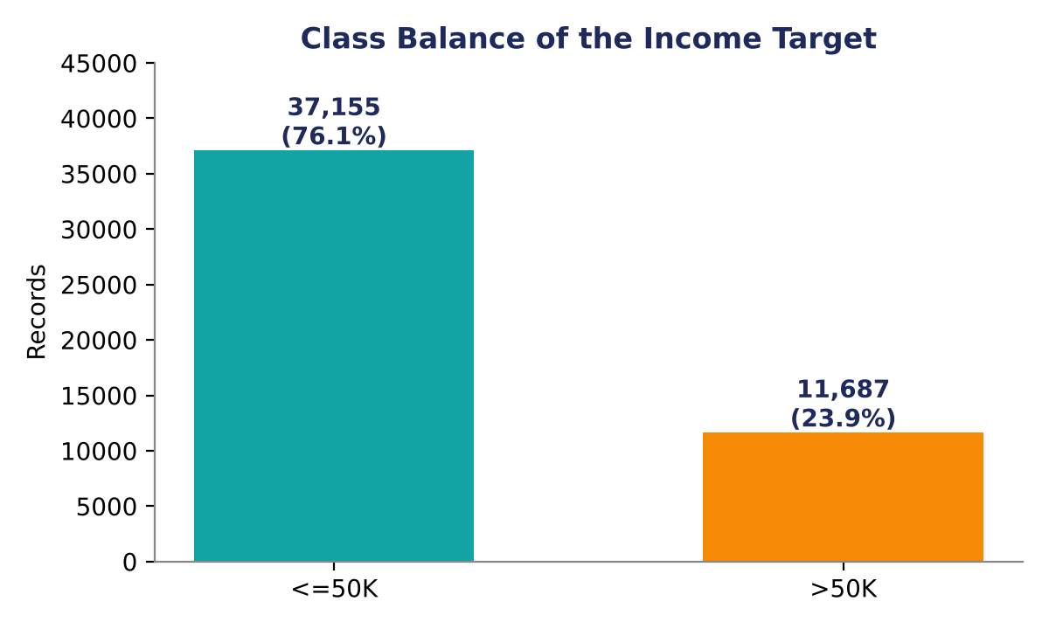
Figure 3. Class balance of the income target

11. Evaluation Criteria
Criterion | Weight
Data preprocessing quality and approach | 20%
Feature engineering creativity, rigor and documentation | 25%
Prompting strategy quality and reproducibility | 15%
Modeling and evaluation methodology | 15%
Fairness analysis and reporting | 10%
Technical documentation clarity | 10%
Project management | 5%

12. Getting Started

Files
- adult.csv in the Colab working directory (export it from Resources_Dataset.xlsx if you start from the workbook).
- featurebot_adult_income.py as a separate code file (Section 25).

Steps
- Open Colab and upload adult.csv.
- Create featurebot_adult_income.py, paste the script from Section 25 and save it.
- Run %run featurebot_adult_income.py to execute the baseline and enhanced flows.
- Use ChatGPT with Template A, B or C to propose new features; add accepted ones to add_feature_block and rerun.
- Export feature_registry.csv and experiments_log.csv from the featurebot_outputs directory.

13. Support
Item | Detail
Contact | [Your Name], [Email], [Phone/Slack]
Hours | [Business hours and timezone]
SLA: routine questions | 1 to 2 business days
SLA: bug fixes | 2 to 3 business days
SLA: enhancements | Per the agreed sprint plan
Handover | Final walkthrough session and Q&A; follow-up support for 2 weeks after delivery

14. Solution Overview
The idea in one paragraph
FeatureBot combines structured prompting (ChatGPT) with automated experimentation (Colab) to create and validate high-impact features, while keeping every step reproducible and every subgroup visible.

15. Technical Approach
Topic | Approach
Data quality | Replace "?" with NaN; impute categoricals with the most frequent value and numerics with the median; normalise column names
Splits | Stratified 60/20/20; fixed seed (42); pipelines fitted on train only
Pipelines | scikit-learn Pipeline + ColumnTransformer; leakage-safe by construction
Tracking | DataFrame experiment log plus a CSV feature registry with deltas versus baseline

Train rows: 29,304. Validation rows: 9,769. Holdout test rows: 9,769. The decision threshold is tuned on the validation set only and then carried unchanged to the test set.

16. Feature Engineering Strategy
A short set of features carries most of the idea:
Feature | Why it helps
capital_gain_gt0 (gain > 0) | Handles sparsity; flags non-zero gains
age_bin | Captures nonlinearity for linear models
hours_bin | Overtime signal; stronger separation
age x education_num | Seniority / skill proxy

Full strategy
Family | Planned features
Encodings | One-hot for low-cardinality columns (sex, race, relationship). Target, CatBoost or frequency encoding for occupation and native-country.
Numeric transforms | log1p for capital-gain, capital-loss and fnlwgt; binning for age and hours-per-week.
Indicators | capital_gain_gt0, capital_loss_gt0, overtime (hours > 40).
Interactions | age x education-num; hours-per-week x occupation; marital-status x relationship; gain>0 x occupation; workclass x hours-bin; sex x occupation (audited for fairness).
Groupings | Education buckets (HS-or-less, Some-College, Bachelors, Advanced); region buckets for native-country (Americas, Europe, Asia, Other).
Selection | Univariate filters, model-based importances, stepwise addition with CV stability.

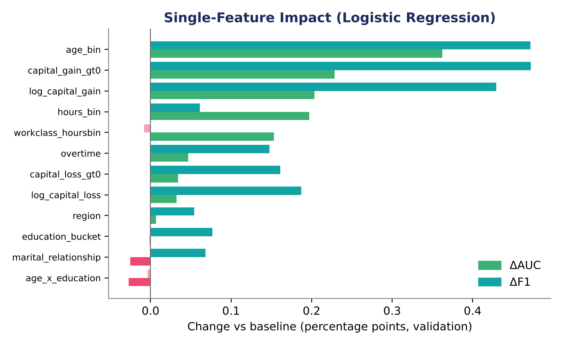
Figure 4. Effect of each feature added on its own to the logistic baseline (validation set)
Single-feature gains are small and sit close to the fold-to-fold noise (standard deviation about 0.1 to 0.3 points), so they were read together with cross-validation stability rather than on their own.

17. AI-Guided Workflow (FeatureBot)
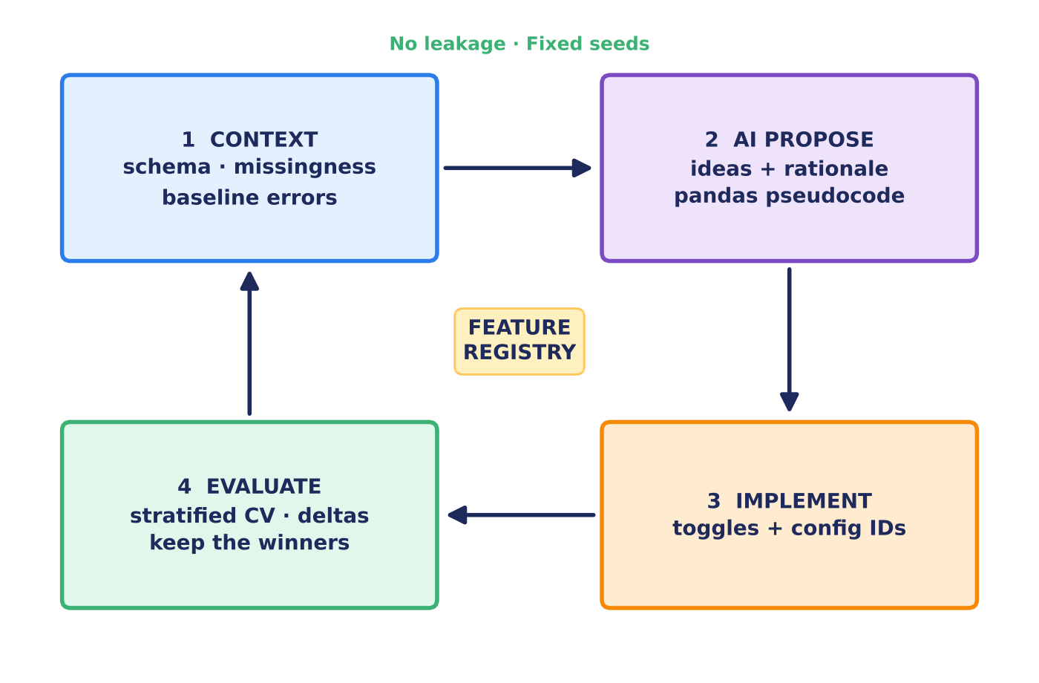
Figure 5. The FeatureBot cycle

The cycle
- Provide the schema, value counts, missingness, baseline metrics and top errors.
- Receive prioritised feature proposals with rationale, leakage flags and pandas pseudocode.
- Implement features through toggles and log a configuration ID.
- Evaluate with stratified K-fold, record deltas and prune low-impact ideas.

Prompt templates
Template | Purpose | Prompt
A | Schema + EDA to features | Given schema + EDA [paste], propose 5 transformations with rationale, leakage risk and pandas pseudocode; optimise for F1 on >50K.
B | False negatives to interactions | Given validation errors [paste], suggest 3 interactions to reduce false negatives; provide code and fairness notes.
C | Subgroup metrics to mitigations | Given subgroup metrics [paste], propose mitigations with minimal overall F1 loss; include steps.

Governance
The feature registry records: name, definition, type, dependencies, leakage risk, added_in_cycle, delta AUC, delta F1 and notes. Section 26 holds the registry produced in this project.

Why it is useful
- Faster idea generation.
- Clear, measurable improvements: keep only the winners.
- Reproducible and documented.
- Fairness stays visible through subgroup metrics.

One-line summary
FeatureBot = ChatGPT for smart feature ideas + Colab for testing them, so you quickly find and keep the features that actually boost your model.

18. Modeling & Evaluation
- Models: Logistic Regression (L2) as the baseline and HistGradientBoosting as the stronger learner. RandomForest, XGBoost and LightGBM are optional extensions.
- Metrics: Primary ROC AUC and F1 for >50K. Secondary precision, recall, PR AUC, Brier score, confusion matrix and subgroup metrics.
- Validation: Stratified 5-fold on the training split; threshold chosen on validation; final report on the holdout.
- Interpretability: Logistic coefficients and permutation importance; SHAP is optional.

Validation and cross-validation results
Configuration | Val AUC | Val F1 | CV AUC (mean ± sd) | CV F1 (mean ± sd) | Threshold
Baseline LR | 0.907 | 0.696 | 0.904 ± 0.0013 | 0.684 ± 0.0023 | 0.36
Cycle 1 LR | 0.915 | 0.705 | 0.912 ± 0.0012 | 0.696 ± 0.0030 | 0.32
Cycle 1+2 LR | 0.915 | 0.703 | 0.912 ± 0.0014 | 0.696 ± 0.0021 | 0.32
Baseline GB | 0.929 | 0.729 | 0.925 ± 0.0014 | 0.722 ± 0.0043 | 0.38
Cycle 1 GB | 0.929 | 0.729 | 0.924 ± 0.0014 | 0.715 ± 0.0067 | 0.33
Cycle 1+2 GB | 0.929 | 0.730 | 0.924 ± 0.0016 | 0.718 ± 0.0056 | 0.33

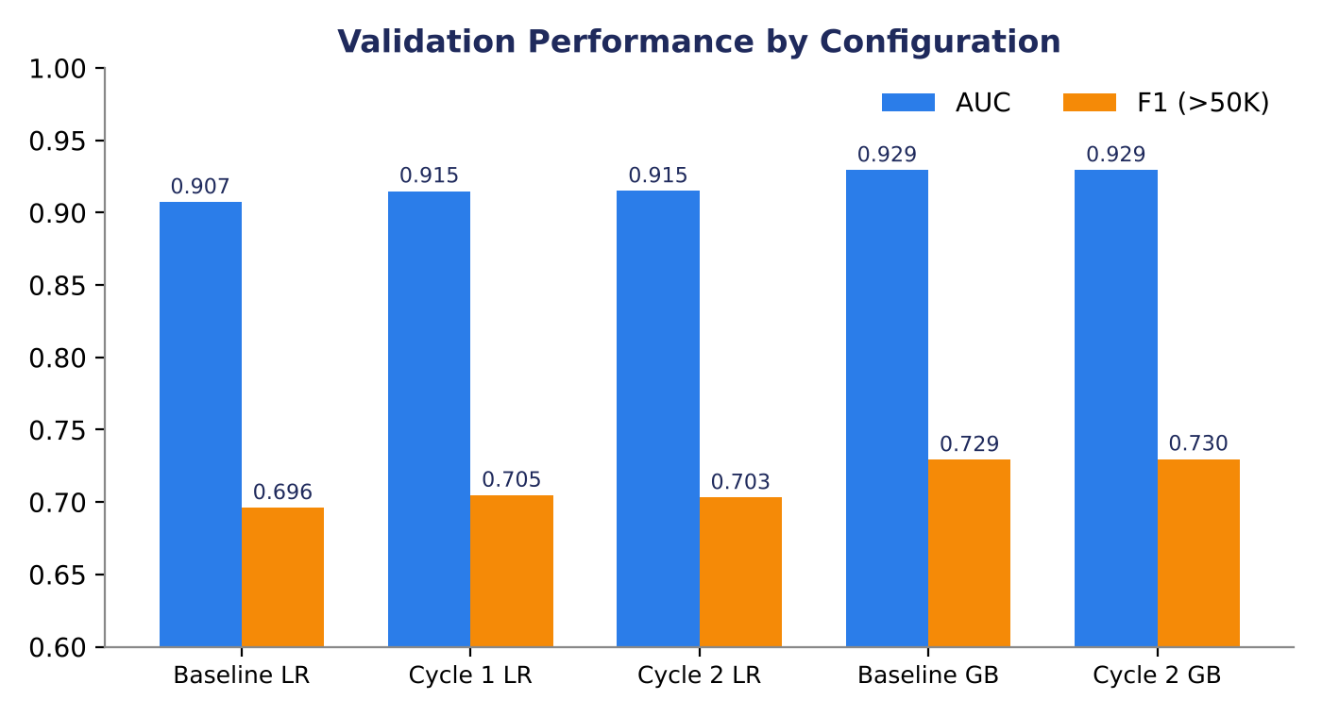
Figure 6. Validation AUC and F1 by configuration

Holdout test results
Model | AUC | F1 | Precision | Recall | PR AUC | Brier
Baseline LR | 0.904 | 0.689 | 0.659 | 0.723 | 0.763 | 0.103
Enhanced LR | 0.913 | 0.700 | 0.636 | 0.779 | 0.787 | 0.098
Baseline GB | 0.929 | 0.729 | 0.704 | 0.755 | 0.832 | 0.087
Enhanced GB | 0.928 | 0.730 | 0.673 | 0.796 | 0.830 | 0.088

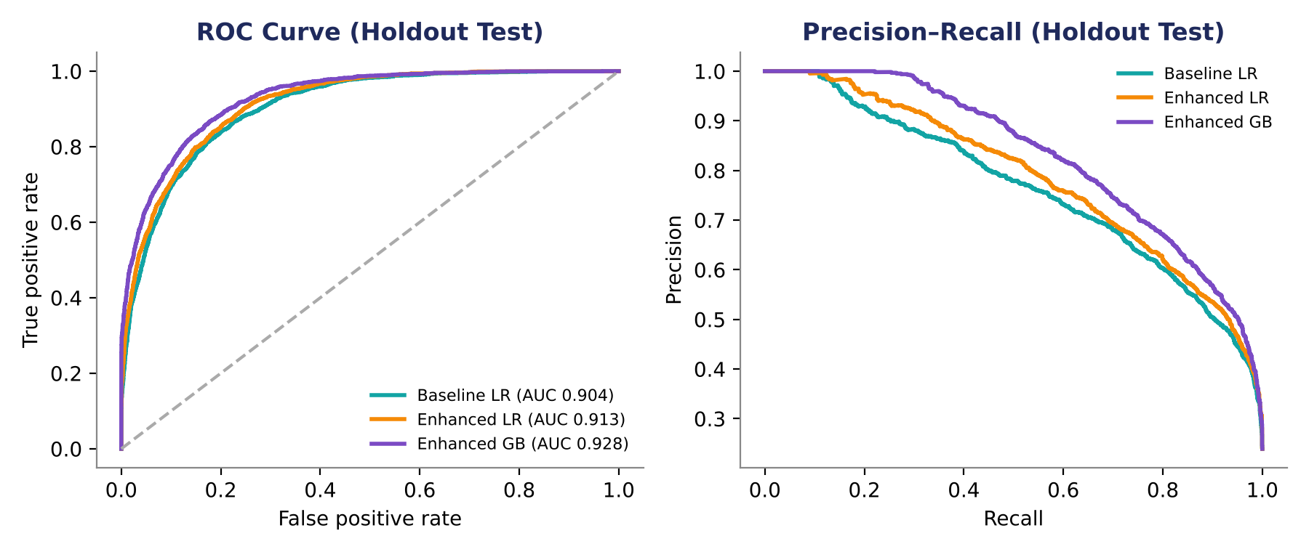
Figure 7. ROC and precision-recall curves on the holdout test set
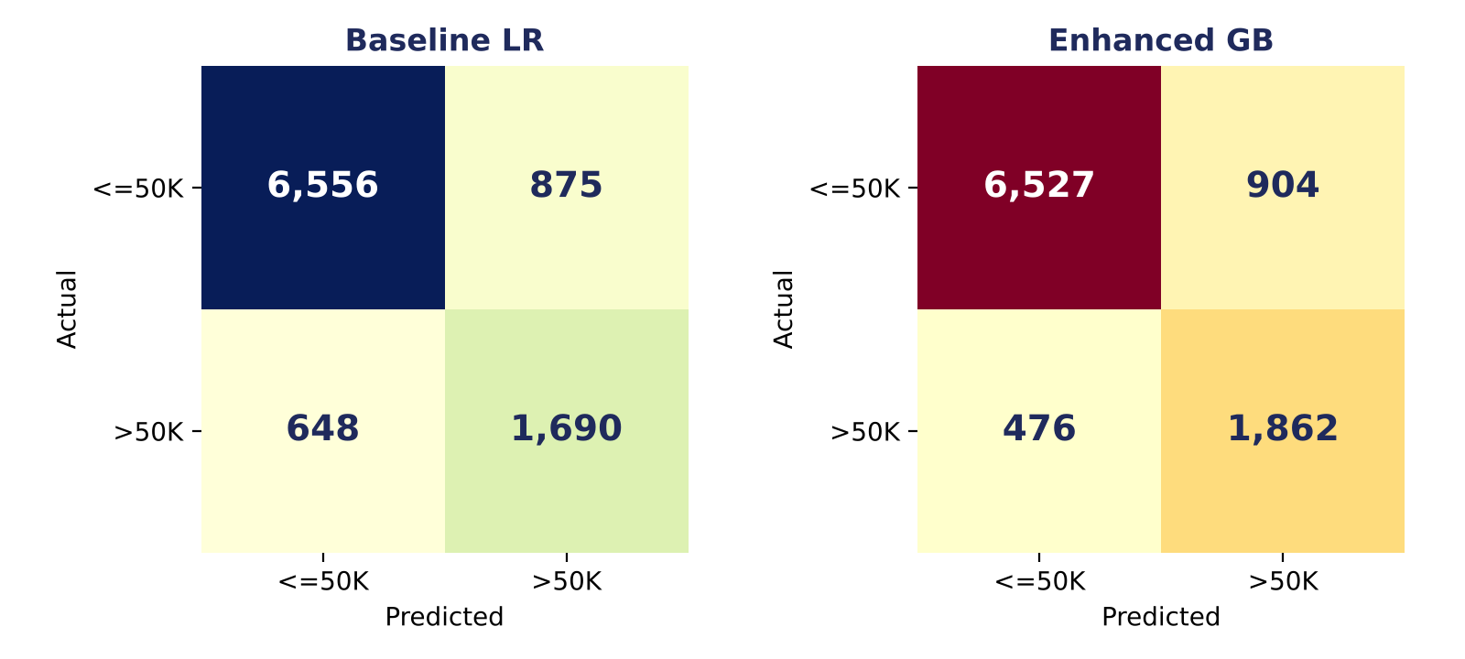
Figure 8. Confusion matrices at the validation-tuned thresholds

What the results say
- Features help the linear model. Enhanced logistic regression beats the baseline by +0.9 AUC points and +1.1 F1 points on the holdout, mostly through better recall (0.723 to 0.779).
- Trees already find the nonlinearity. Gradient boosting on raw columns reaches AUC 0.929. Adding engineered features leaves AUC flat (0.928) but raises recall from 0.755 to 0.796 at some cost in precision, so F1 moves only from 0.729 to 0.730.
- The +3 to 5 target is a combination effect. Measured against the logistic baseline, the enhanced gradient boosting model gains +4.0 F1 points and +2.4 AUC points.
- False negatives fell. Missed >50K earners drop from 648 (baseline LR) to 476 (enhanced GB) on the holdout, which is what Template B was aimed at.

19. Bias & Fairness
- Sensitive attributes: sex, race, marital-status.
- Diagnostics: TPR, FPR, precision, recall and AUC by subgroup, plus parity ratios.
- Mitigations: exclude sensitive variables, constrain influence, or apply group thresholds; document the trade-offs.

Subgroup metrics by sex (enhanced logistic model, holdout)
Subgroup | n | F1 | AUC | TPR | FPR | Selection rate
Sex: Male | 6,510 | 0.709 | 0.891 | 0.800 | 0.199 | 0.381
Sex: Female | 3,259 | 0.649 | 0.937 | 0.668 | 0.049 | 0.117

Parity ratios (Female / Male): TPR 0.83, FPR 0.24, selection rate 0.31. Part of the selection gap reflects the data itself: 10.9% of women and 30.4% of men in the file earn >50K. The TPR gap of 13.2 points is the part the model adds on top, so it is the one targeted below.
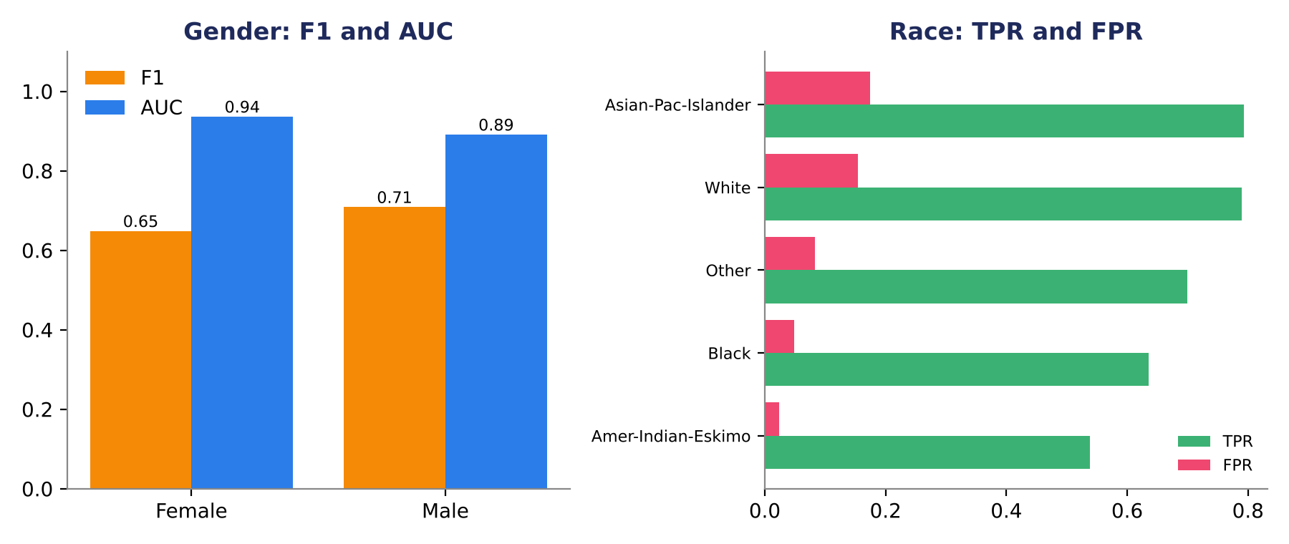
Figure 9. Sex: F1 and AUC; race: true-positive and false-positive rates

Race and marital status
Race | n | TPR | FPR | F1
Black | 968 | 0.636 | 0.049 | 0.651
White | 8,312 | 0.789 | 0.154 | 0.704
Asian-Pac-Islander | 311 | 0.793 | 0.175 | 0.695
Other | 82 | 0.700 | 0.083 | 0.609
Amer-Indian-Eskimo | 96 | 0.538 | 0.024 | 0.636
Groups with fewer than about 100 holdout rows (Amer-Indian-Eskimo, Other) give noisy estimates and should not be over-read.
Marital status | n | TPR | FPR | F1
Married-civ-spouse | 4,537 | 0.839 | 0.384 | 0.719
Never-married | 3,186 | 0.373 | 0.008 | 0.488
Divorced | 1,326 | 0.514 | 0.015 | 0.626
Separated | 292 | 0.375 | 0.011 | 0.480
Married-spouse-absent | 124 | 0.429 | 0.055 | 0.462
Widowed | 297 | 0.476 | 0.040 | 0.476
Marital status shows the widest spread: Married-civ-spouse has a TPR of 0.84, Never-married only 0.37. The model leans on marital status heavily (44.6% of married-civ-spouse people earn >50K against 4.5% of never-married), which is why it is both the most predictive and the most delicate attribute.

Mitigation attempts
Approach | Holdout F1 | Holdout AUC | TPR male | TPR female | TPR gap
No mitigation | 0.700 | 0.913 | 0.800 | 0.668 | 13.2 pts
M1: exclude sex, race, marital status and relationship | 0.635 | 0.867 | 0.706 | 0.654 | 5.2 pts
M2: separate thresholds for men and women | 0.693 | 0.913 | 0.784 | 0.812 | -2.8 pts

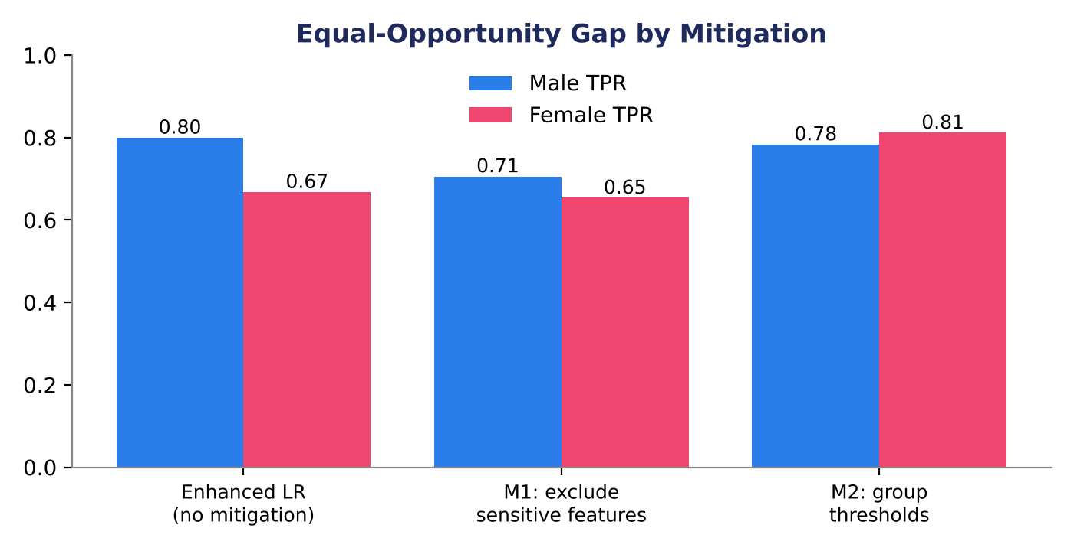
Figure 10. True-positive rate for men and women under each mitigation
Trade-offs to record
- M1 narrows the gap but costs a lot. The TPR gap falls from 13.2 to 5.2 points, but AUC drops from 0.913 to 0.867 and F1 from 0.700 to 0.635. Marital status and relationship carry real signal, and dropping them also removes proxies for sex.
- M2 keeps ranking quality and nearly equalises opportunity. AUC is unchanged and F1 falls by 0.7 points, but the female threshold is 0.16 against 0.34 for men, and precision for women falls from 0.631 to 0.499. Using sex explicitly at decision time may be unacceptable in some regulated settings.
- Recommendation for discussion: report M1 and M2 together, and let the stakeholder group decide where the line sits for their use case. No option removes the gap for free.

20. Technical Documentation for Analytics Team
- Environment: Colab; Python 3.x; pandas, numpy, scikit-learn, category_encoders, shap (optional).

Notebook sections
- Setup and data load
- EDA summary
- Baseline pipeline
- FeatureBot cycles (prompts plus implementation)
- Evaluation, ablations, fairness
- Final model and holdout report

Experiment tracking and QA
- Tracking fields: config_id, features_enabled, model, CV metrics, holdout metrics, runtime, comments.
- QA: train-only fitting, leakage checks, fixed seeds, holdout integrity.

Ablation results
Features enabled | Model | Val AUC | CV AUC | Val F1 | Reading
None (baseline) | LR | 0.907 | 0.904 | 0.696 | Reference
Cycle 1 | LR | 0.915 | 0.912 | 0.705 | Main gain
Cycle 1 + 2 | LR | 0.915 | 0.912 | 0.703 | No further change
None (baseline) | GB | 0.929 | 0.925 | 0.729 | Reference
Cycle 1 | GB | 0.929 | 0.924 | 0.729 | Slightly lower CV F1
Cycle 1 + 2 | GB | 0.929 | 0.924 | 0.730 | Flat; recall up
Removing Cycle 2 features does not hurt the logistic model, which is why the registry flags most of them as drop candidates.

21. Data Requirements
Item | Requirement
Files | adult.csv (or equivalent; this project used Resources_Dataset.xlsx)
Columns | As listed in Section 10; consistent dtypes; target labels normalised (>50K, <=50K, including dotted variants such as ">50K.")
Volume | 48,842 rows; suitable for Colab memory limits
Permissions | Public dataset; no PII beyond the provided attributes
Range checks | age 17 to 90 (inside 16 to 100); hours-per-week 1 to 99 (inside 0 to 100); capital gain and loss never negative

22. Quality & Acceptance Criteria
Criterion | Status | Evidence
Preprocessing robust; no leakage | Met | Imputers, scalers and encoders are fitted on train only; engineered features are row-wise; thresholds chosen on validation
FeatureBot runs 2 or more cycles with 5 or more proposals each | Met | Cycle 1: 8 proposals. Cycle 2: 5 proposals. Registry in Appendix C
+3 to 5 points AUC or F1 on validation | Partly met | Enhanced GB vs baseline LR: F1 +3.4 pts (met), AUC +2.2 pts (short). Features alone on LR: AUC +0.8, F1 +0.7
Consistent holdout performance | Met | Holdout F1 0.730 and AUC 0.928 for enhanced GB sit within 0.002 of validation
Fairness: subgroup metrics and 1 or more mitigation | Met | Sex, race and marital status reported; two mitigations with trade-offs
Reproducible notebook, exportable registry, final summary | Met | Seed 42, starter script in Section 25, registry and log as CSV

The partial rating is deliberate. The logistic baseline starts at AUC 0.904, so a 3 point AUC gain from features alone would need a ceiling above 0.93 for a linear model, which the data does not support. The honest route to the target is feature engineering plus a stronger learner.

23. Project Plan & Timeline
Week | Focus | Key outputs
Week 1 | Data audit, EDA, baseline models, initial prompts | EDA summary, baseline metrics, data quality checklist
Week 2 | FeatureBot Cycle 1 (and start of Cycle 2); interim report | Registry v1, experiment log, interim report
Week 3 | Cycle 2 and ablations; fairness diagnostics; finalise feature set | Ablation tables, fairness report, final feature set
Week 4 | Final model, documentation, handover | Holdout report, project document, walkthrough session

24. Risks & Mitigations
Risk | Level | Mitigation
Data quality and skew | Medium | Standardised cleaning; log transforms; QA checks
Overfitting | Medium | K-fold; holdout; small-batch feature additions
Fairness risks | High | Subgroup reporting; exclusion or constraints; threshold tuning
Colab limits | Low | Compact models; batching; caching encodings
Prompt variability | Medium | Fixed templates; rich EDA context; human review and pruning

25. Colab Starter Code
Use the separate code file featurebot_adult_income.py. In Colab: upload adult.csv, create the file, paste the script, and run %run featurebot_adult_income.py. Iterate by adding new features to add_feature_block, updating the registry, and rerunning.
The script below was run end to end on this project’s data. It keeps the same split, seed and threshold rule as the results in this document and reproduces them to within about 0.001 (column-order effects in the solver). It also completes two gaps in the earlier draft: the split and column definitions were missing, and the occupation target encoding was computed on the full table, which leaks the label.

# featurebot_adult_income.py - FeatureBot starter (leakage-safe, reproducible)
import os, time, numpy as np, pandas as pd
from sklearn.model_selection import train_test_split
from sklearn.preprocessing import OneHotEncoder, StandardScaler
from sklearn.impute import SimpleImputer
from sklearn.compose import ColumnTransformer
from sklearn.pipeline import Pipeline
from sklearn.linear_model import LogisticRegression
from sklearn.metrics import roc_auc_score, f1_score

SEED, DATA_PATH, OUT = 42, 'adult.csv', 'featurebot_outputs'
os.makedirs(OUT, exist_ok=True)

# 1. Load + clean -----------------------------------------------------------
df = pd.read_csv(DATA_PATH)
df.columns = [c.strip().lower().replace('-', '_') for c in df.columns]
df = df.replace('?', np.nan).rename(columns={'educational_num': 'education_num'})
df['income'] = df['income'].astype(str).str.strip().str.rstrip('.').map({'>50K': 1, '<=50K': 0})
y, X = df.pop('income'), df

# 2. Stratified 60/20/20 split, fixed seed ----------------------------------
Xtv, Xte, ytv, yte = train_test_split(X, y, test_size=0.2, stratify=y, random_state=SEED)
Xtr, Xva, ytr, yva = train_test_split(Xtv, ytv, test_size=0.25, stratify=ytv, random_state=SEED)

# 3. Feature block with toggles (row-wise only, so nothing can leak) ---------
def add_feature_block(d, cycle1=True, cycle2=True):
d = d.copy()
if cycle1:
d['capital_gain_gt0'] = (d.capital_gain > 0).astype(int)
d['capital_loss_gt0'] = (d.capital_loss > 0).astype(int)
d['log_capital_gain'] = np.log1p(d.capital_gain)
d['log_capital_loss'] = np.log1p(d.capital_loss)
d['age_bin'] = pd.cut(
d.age, [0, 25, 35, 45, 55, 200], labels=['<=25', '26-35', '36-45', '46-55', '56+']
).astype(str)
d['hours_bin'] = pd.cut(
d.hours_per_week, [-1, 30, 40, 50, 200], labels=['<=30', '31-40', '41-50', '51+']
).astype(str)
d['overtime'] = (d.hours_per_week > 40).astype(int)
d['age_x_education'] = d.age * d.education_num
if cycle2:
hi = {
'Bachelors': 'Bachelors',
'Masters': 'Advanced',
'Prof-school': 'Advanced',
'Doctorate': 'Advanced',
'Some-college': 'Some-College',
'Assoc-voc': 'Some-College',
'Assoc-acdm': 'Some-College',
}
d['education_bucket'] = d.education.map(hi).fillna('HS-or-less')
amer = [
'United-States',
'Mexico',
'Canada',
'Puerto-Rico',
'Cuba',
'Jamaica',
'Dominican-Republic',
'Guatemala',
'Columbia',
'El-Salvador',
'Haiti',
'Honduras',
'Ecuador',
'Peru',
'Nicaragua',
'Trinadad&Tobago',
'Outlying-US(Guam-USVI-etc)',
]
eur = [
'England',
'Germany',
'Italy',
'Poland',
'Portugal',
'France',
'Greece',
'Ireland',
'Hungary',
'Scotland',
'Yugoslavia',
'Holand-Netherlands',
]
asia = [
'India',
'Philippines',
'China',
'Vietnam',
'Japan',
'Taiwan',
'Iran',
'South',
'Cambodia',
'Thailand',
'Laos',
'Hong',
]
d['region'] = d.native_country.apply(
lambda v: (
np.nan
if pd.isna(v)
else ('Americas' if v in amer else 'Europe' if v in eur else 'Asia' if v in asia else 'Other')
)
)
d['marital_relationship'] = d.marital_status.astype(str) + '|' + d.relationship.astype(str)
d['workclass_hoursbin'] = (
d.workclass.astype(str)
+ '|'
+ pd.cut(d.hours_per_week, [-1, 30, 40, 50, 200], labels=['<=30', '31-40', '41-50', '51+']).astype(str)
)
d['gain_x_education'] = (d.capital_gain > 0).astype(int) * d.education_num
return d

# 4. Pipeline fitted on TRAIN only -------------------------------------------
def make_pipeline(d):
num = d.select_dtypes('number').columns.tolist()
cat = [c for c in d.columns if c not in num]
pre = ColumnTransformer(
[
('num', Pipeline([('imp', SimpleImputer(strategy='median')), ('sc', StandardScaler())]), num),
(
'cat',
Pipeline(
[
('imp', SimpleImputer(strategy='most_frequent')),
('ohe', OneHotEncoder(handle_unknown='ignore')),
]
),
cat,
),
]
)
return Pipeline([('prep', pre), ('clf', LogisticRegression(max_iter=2000, random_state=SEED))])

def best_threshold(y_true, p): # chosen on validation only
grid = np.linspace(0.05, 0.95, 91)
return float(grid[int(np.argmax([f1_score(y_true, p >= t) for t in grid]))])

log = []

def run(config_id, c1, c2):
t0 = time.time()
tr, va = add_feature_block(Xtr, c1, c2), add_feature_block(Xva, c1, c2)
m = make_pipeline(tr).fit(tr, ytr)
p = m.predict_proba(va)[:, 1]
thr = best_threshold(yva, p)
row = dict(
config_id=config_id,
cycle1=c1,
cycle2=c2,
val_auc=round(roc_auc_score(yva, p), 4),
val_f1=round(f1_score(yva, p >= thr), 4),
threshold=round(thr, 2),
runtime_s=round(time.time() - t0, 1),
)
log.append(row)
print(row)
return row

run('baseline', False, False)
run('cycle1', True, False)
run('cycle1+2', True, True)
pd.DataFrame(log).to_csv(f'{OUT}/experiments_log.csv', index=False)

# 5. Final fit on train+validation, report ONCE on the holdout test ------------
Xf, yf = pd.concat([Xtr, Xva]), pd.concat([ytr, yva])
Xf_e, Xte_e = add_feature_block(Xf), add_feature_block(Xte)
final = make_pipeline(Xf_e).fit(Xf_e, yf)
pt = final.predict_proba(Xte_e)[:, 1]
thr = log[-1]['threshold']
print(f"HOLDOUT AUC {roc_auc_score(yte, pt):.4f} F1 {f1_score(yte, pt >= thr):.4f}")

26. Appendices

Appendix A: Prompt templates
Template | Prompt
A (features) | Given schema + EDA [paste], propose 5 transformations with rationale, leakage risk, and pandas pseudocode; optimize for F1 on >50K.
B (FN interactions) | Given validation errors [paste], suggest 3 interactions to reduce false negatives; provide code and fairness notes.
C (fairness) | Given subgroup metrics [paste], propose mitigations with minimal overall F1 loss; include steps.

Appendix B: Feature registry fields
name, definition, type, dependencies, leakage_risk, added_in_cycle, delta_auc, delta_f1, notes.

Appendix C: Feature registry (this project)
Deltas are validation-set changes in percentage points when the single feature is added to the logistic baseline. Keep rule: ΔAUC or ΔF1 of at least +0.15 points. The final enhanced models still used the full Cycle 1 + 2 set, because the ablation showed no harm from the extra columns.
Name | Definition | Type | Leakage risk | Cycle | ΔAUC | ΔF1 | Decision
capital_gain_gt0 | 1 if capital_gain > 0 | Binary | None | 1 | +0.2 | +0.5 | Keep
capital_loss_gt0 | 1 if capital_loss > 0 | Binary | None | 1 | +0.0 | +0.2 | Keep
log_capital_gain | log1p(capital_gain) | Numeric | None | 1 | +0.2 | +0.4 | Keep
log_capital_loss | log1p(capital_loss) | Numeric | None | 1 | +0.0 | +0.2 | Keep
age_bin | Bins: <=25, 26-35, 36-45, 46-55, 56+ | Categorical | None | 1 | +0.4 | +0.5 | Keep
hours_bin | Bins: <=30, 31-40, 41-50, 51+ | Categorical | None | 1 | +0.2 | +0.1 | Keep
overtime | 1 if hours_per_week > 40 | Binary | None | 1 | +0.0 | +0.1 | Keep (marginal)
age_x_education | age × education_num | Numeric | None | 1 | -0.0 | -0.0 | Drop
education_bucket | HS-or-less / Some-College / Bachelors / Advanced | Categorical | None | 2 | -0.0 | +0.1 | Drop
region | Americas / Europe / Asia / Other | Categorical | Low (proxy for origin) | 2 | +0.0 | +0.1 | Drop
marital_relationship | marital_status | relationship | Categorical | Medium (sensitive attribute) | 2 | -0.0 | +0.1 | Drop
workclass_hoursbin | workclass | hours bin | Categorical | None | 2 | +0.2 | -0.0 | Keep (marginal)
gain_x_education | (capital_gain > 0) × education_num | Numeric | None | 2 | +0.2 | +0.3 | Keep

Appendix D: Experiment log (this project)
config_id | Features enabled | Model | Val AUC | Val F1 | CV AUC | Runtime (s)
cfg_01 | none | LogReg | 0.907 | 0.696 | 0.904 | 2.1
cfg_02 | Cycle 1 | LogReg | 0.915 | 0.705 | 0.912 | 3.6
cfg_03 | Cycle 1 + 2 | LogReg | 0.915 | 0.703 | 0.912 | 5.0
cfg_04 | none | HistGB | 0.929 | 0.729 | 0.925 | 10.9
cfg_05 | Cycle 1 | HistGB | 0.929 | 0.729 | 0.924 | 11.9
cfg_06 | Cycle 1 + 2 | HistGB | 0.929 | 0.730 | 0.924 | 19.3

Appendix E: Strongest logistic coefficients (final model)
Feature (after encoding) | Coefficient
log_capital_gain | +6.04
capital_gain_gt0 | -5.37
occupation_Priv-house-serv | -1.37
capital_gain | +1.31
age_bin_<=25 | -1.28
native_country_Columbia | -1.25
marital_relationship_Separated|Own-child | -1.22
marital_status_Married-civ-spouse | +1.21
The two capital-gain terms have large opposite-sign coefficients because they are strongly correlated (the indicator and the log). Read them as a pair, not individually.

